**2017**

**E-Project**

[Ask Me Mobile]

Aptech Computer Education



Submitted By

[Asif Jamal]

[Talha Qureshi]

[Muhammad Asif]

[Sahib Khan]

[Wasif Hussain]

**Submitted To**

[eprojects@aptech.ac.in](mailto:eprojects@aptech.ac.in)

**Project Instructor**

Ms. Marium

**Curriculum Code**

6673

Table of Contents

Project Certification 3

Welcome to Ask Me Mobile 4

PROBLEM STATEMENT: 4

Requirement Summary 5

Task Sheet 8

Site Map 9

List of Validation 10

Submission Checklist 11

12

# Project Certification

This is to certify that,

Mr.  
**(<Asif Jamal>,<**Enrollment>**)**

**(<Talha Azhar Qureshi>, <**Enrollment>**)**

**(<Muhammad Asif >, <**Enrollment>**)**

**(<Muhammad Sabih Khan>, <**Enrollment>**)**

**(<Syed Wasif Hussain>, <**Enrollment>**)**

Has successfully Designed & Developed

**<Ask Me Mobile>**

Submitted by:**Muhammad Asif Jamal, Mohammad Talha Azhar Qureshi, Muhammad Asif, Muhammad Sahib Khan, Syed Wasif Hussain.**

Date of Issue:

**<26-March-2017>**

Welcome to Ask Me Mobile

## 

## PROBLEM STATEMENT:

ASKME Ltd. Is a Multi-National Company providing Information services to General People they have been providing information to people through Telephone calls which could include anything from Pin to Piano. Their major source of income comes from informing the customers about those products first for which ASKME is getting paid for.

**Problem Areas**

After analyzing the Queries coming in form various Customers mostly are related to information regarding Cell phones which could be one or all of the follow

1. What is the Cell Phone Model Number with XYZ features?
2. What are the Features in XYZ cell?
3. What is the current price of the XYZ cell phone?
4. How is XYZ cell phone Different from ABC phone?
5. What is the approximate price of XYZ phone?

And many more…

As you can see there are a lot of queries which cannot be answered online or would be very difficult for the Call executive to explain the entire features of the product which again would consume a lot of Call time of the executives as well.

Requirement Summary

Depending on the decision given by the management on the Web site to be created following are the requirements based on which the web site needs to be developed.

1. The Home Page should be created making use of Frames.
2. A Menu should be created which would categorize all the information about the features provided in the Site For e.g. a Menu for Various Cell phones, a Menu for Features of Cell phones etc. etc. something like that.
3. The information should be categorized according to the Brand names of Mobiles like if a User wants to see only Nokia Phones then he click on Some Nokia Link/button etc and he will see only That Brand phones and so on.
4. A Brief summary of features of Individual phones should be displayed on the Web Page along with the Cell phone but detailed Features should be stored in Individual Word documents which can be downloaded or viewed by the User who wishes to see the same.
5. A Comparison Web Page should also be there where there is Phone comparisons done with various models of same brand or various models of various brands.
   * The Comparison information should be provided in Tabular format comparing the features of different phones.
   * This information would be for 5 Phones of similar brands and 2 phones of different brands for 1 month and then it will change so for the time being the Page should handle the above requirement.
6. The Colour Schemes should be soothing, more of Pastel Colors can be chosen for the same.
7. When a particular brand phones are being displayed the background image of the Web page should show the Logo of that brand for e.g. if Nokia Phones are being displayed then that page should have the Logo of NOKIA as the background image and the same in case of other Brands.
8. There should be a “Contact Us” page which will have the Address of the Company which is as follows and the mail address which when clicked will invoke the local mail client from where they can send an email.

Address of the Company: A-65, ACME Co., Street no 12, New York

Phone Numbers: +001-28272300, 2466, 2469

Email Address: webmaster@cellinfo.com

1. The information on the mobile phones and all can be picked up from the Sites of Nokia, Samsung etc.
2. To avoid creation of html pages you can make use of layers, flash buttons and other components of Dreamweaver for creation of pages.
3. The appearance and organization of the site will carry more chances of your selection for getting the contract so both the factors are important to be considered.

**Hardware/ Software Requirements**

**Hardware**

* A minimum computer system that will help you access all the tools in the courses is a Pentium 166 or better
* 64 Megabytes of RAM or better

**Software**

* Notepad/HTML editor
* Dreamweaver
* IE 5.0/ Netscape 6.0

**Project Duration**

1. Analysis-18 Hrs.
2. Design – 22 Hrs.
3. Development –20Hrs
4. Testing – 12 Hrs.
5. Documentation -11 hrs.

|  |  |  |  |  |
| --- | --- | --- | --- | --- |
| Analysis | Design | Development | Testing | Documentation |

|  |  |  |  |  |  |  |  |  |  |  |  |  |  |  |  |  |  |  |  |  |  |  |  |  |  |  |  |  |  |
| --- | --- | --- | --- | --- | --- | --- | --- | --- | --- | --- | --- | --- | --- | --- | --- | --- | --- | --- | --- | --- | --- | --- | --- | --- | --- | --- | --- | --- | --- |
| 23 | 24 | 25 | 26 | 27 | 28 | 29 | 30 | 31 | 1 | 2 | 3 | 4 | 5 | 6 | 7 | 8 | 9 | 10 | 11 | 12 | 13 | 14 | 15 | 16 | 17 | 18 | 19 | 20 | 21 |

|  |  |  |  |  |  |
| --- | --- | --- | --- | --- | --- |
| **No.** | **Task** | **Actual Start Date** | **Actual Days** | **Team Mate Name** | **Status** |
| 1. | Case Study | 11th Jan 2012 | 2 | Talha Qureshi  Asif Jamal  M Asif  Sabih Khan  Syed Wasif | Completed |
| 2. | Graphics Designing | 16th Jan 2012 | 9 | Talha Qureshi  Asif Jamal | Completed |
| 3. | Site Interface Designing | 20th Jan 2012 | 8 | Talha Qureshi  Asif Jamal  M Asif | Completed |
| 4. | Material Searching | 12th Jan 2012 | 3 | Sabih Khan  Syed Wasif | Completed |
| 5. | Site Testing/Publishing | 1th Feb 2012 | 6 | Talha Qureshi  Asif Jamal  M Asif | Completed |
| 6. | Documentation | 9th Feb 2012 | 2 | Talha Qureshi  Asif Jamal  M Asif  Syed Wasif | Completed |

# Task Sheet

# 

# Site Map

**Ask Me Mobile**

Comparison

Products

Home

Gallery

Contact Us

About Us

IPhone 5

IPhone

IPhone 6

Oppo

IPhone 6 Plus

Oppo N3

Blackberry

IPhone 7

Oppo Find 7

IPhone 7 Plus

Oppo F3 Plus

Samsung

Samsung S7

Samsung S7 Edge

Blackberry DTEK50

Oppo R5

Oppo R7 Plus

Samsung S6 Edge

Blackberry Curve 9380

Blackberry Priv

Huawei

Samsung S5

Samsung S6

Blackberry Torch 9860

Huawei Nexus 6p

Blackberry Bold 9650

Huawei Mate 9

Huawei Mate 9 Black

Huawei P9 Plus

Huawei P8 max

# List of Validation

|  |  |
| --- | --- |
| Option | Validation |
| Fields in Form should not be Null | Yes |
| Hyperlinks Have Alternating Text | No |
| Search Pages | Yes |
| Homepage Has Forward Only Link | Yes |
| All Web pages have link back to Homepage | Yes |
| Request Quote Form Included | No |
| All Functions Are Compatible with Firefox | Yes |
| All Functions Are Compatible with IE | No |

# Submission Checklist

|  |  |  |  |
| --- | --- | --- | --- |
| **S.NO** | **LIST OF ITEMS** | **Remarks** | **COMMENTS** |
| 1. | Do All Pages Linked together | **Yes** |  |
| 2. | All Hyperlinks working | **Yes** |  |
| 3. | Page Colors As Per Common Guidelines | **Yes** |  |
| 4. | Site Browser Compatible | **No** | Tested in only FireFox |
| 5. | Image Slicing | **Yes** | Using Adobe Photoshop,AdobeFlash |
| 6. | Feedback Form Included | **Yes** |  |
| 7. | Project Zip File | **Yes** | Created using WinRAR |

Index

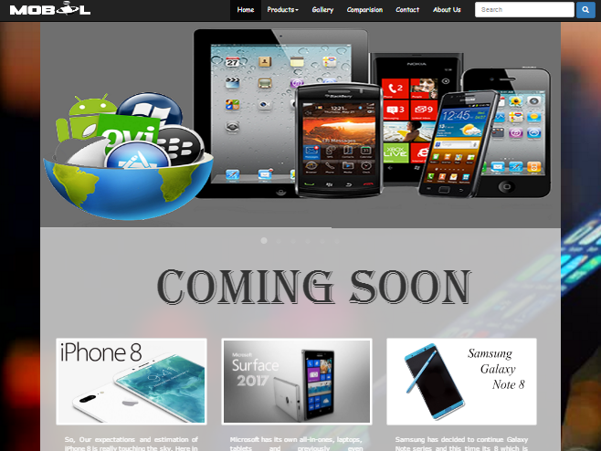

Product

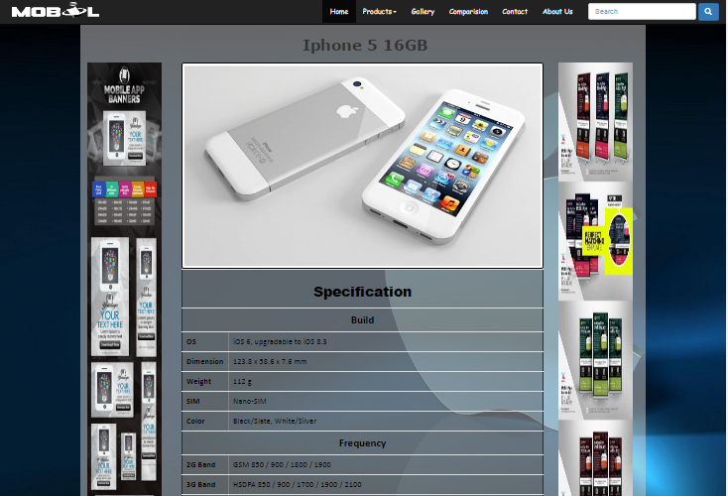

Product

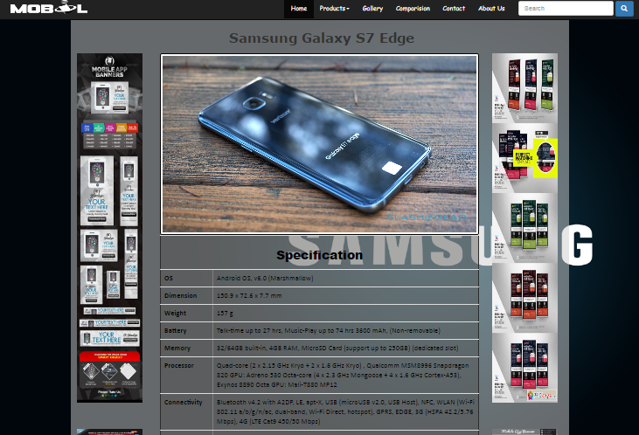

Product

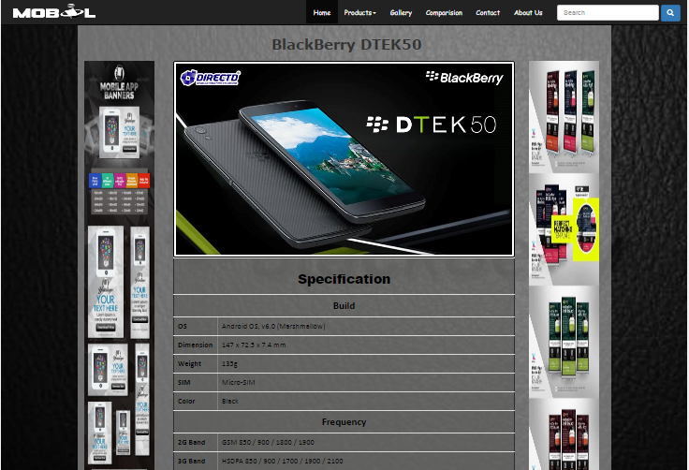

Product

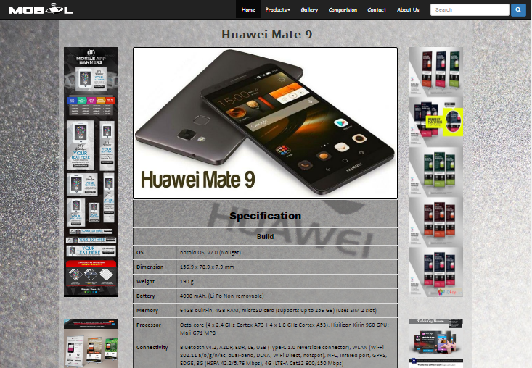

Product

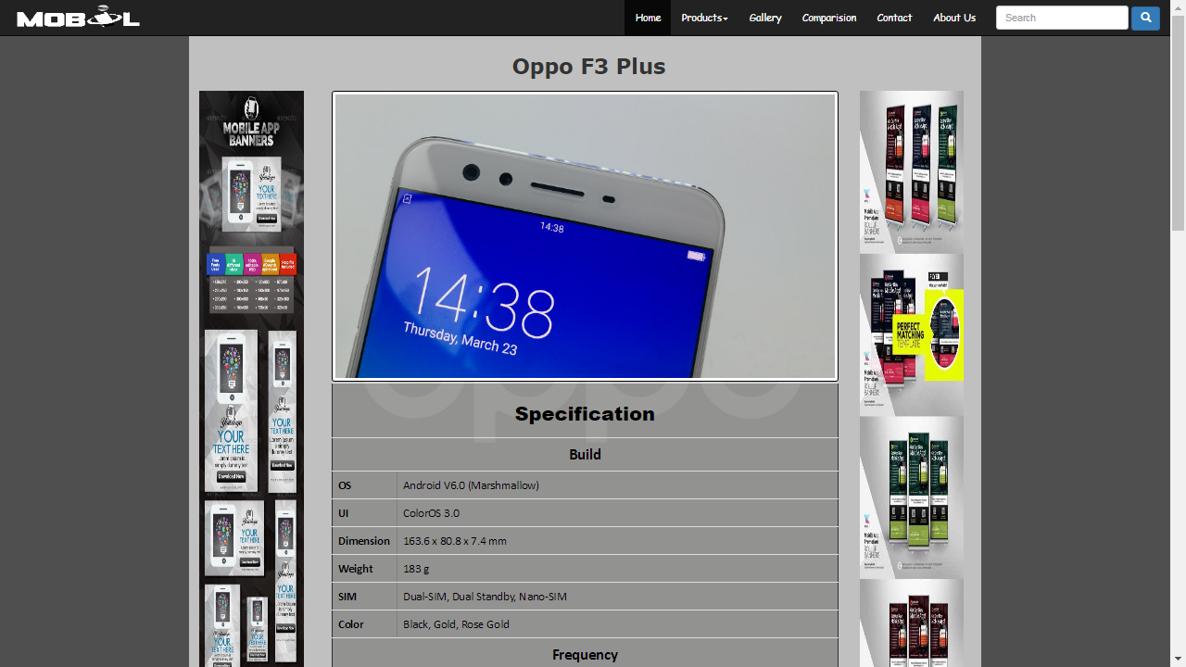

Gallery

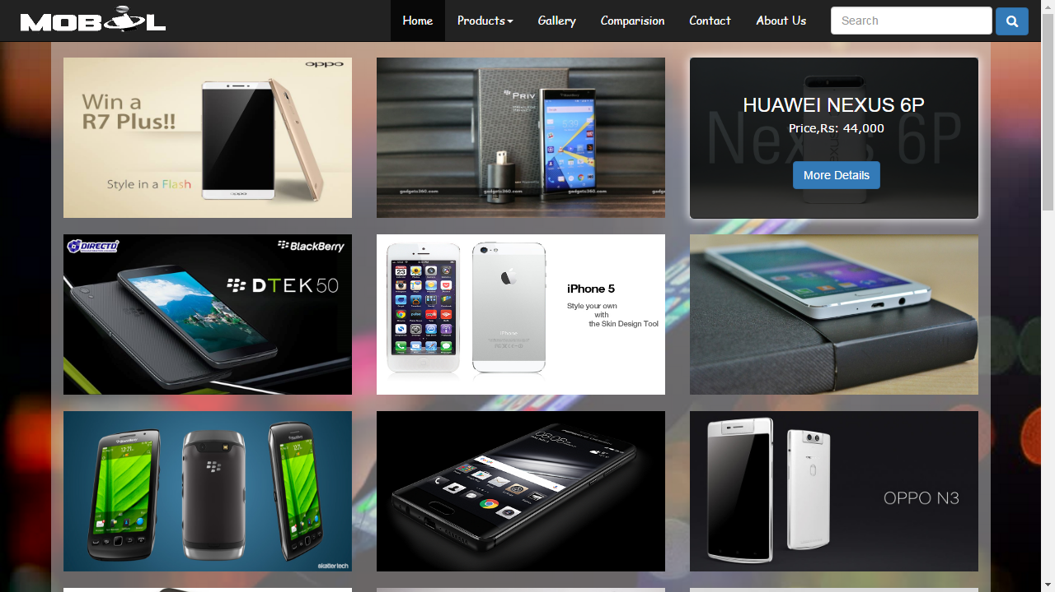

Comparision

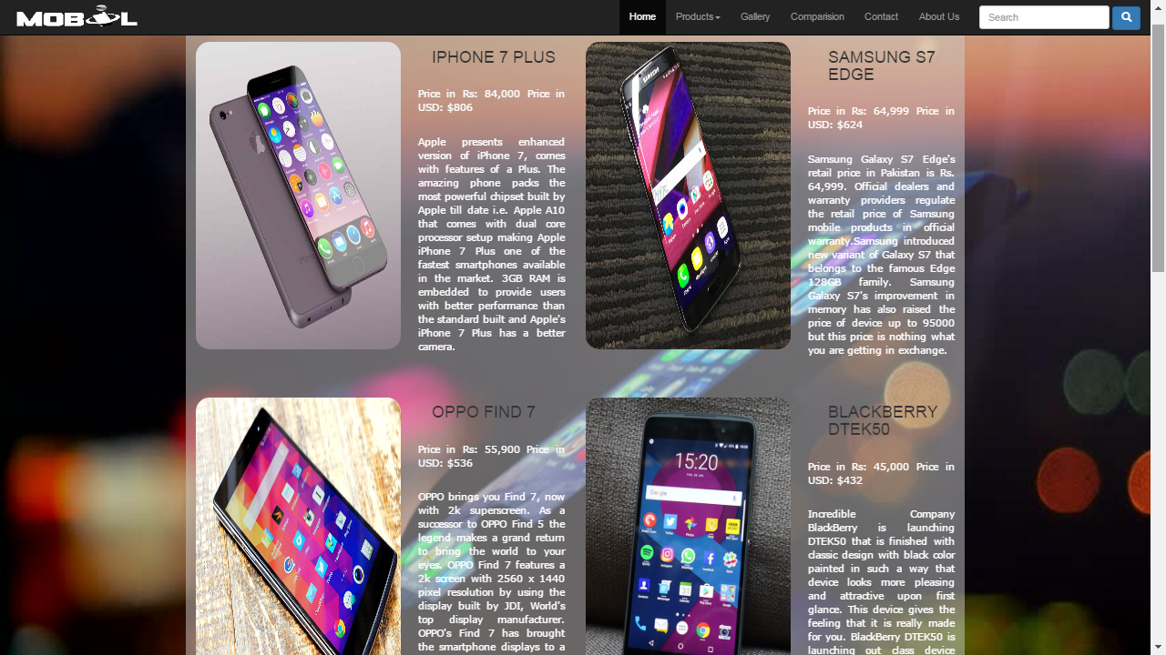

Contact

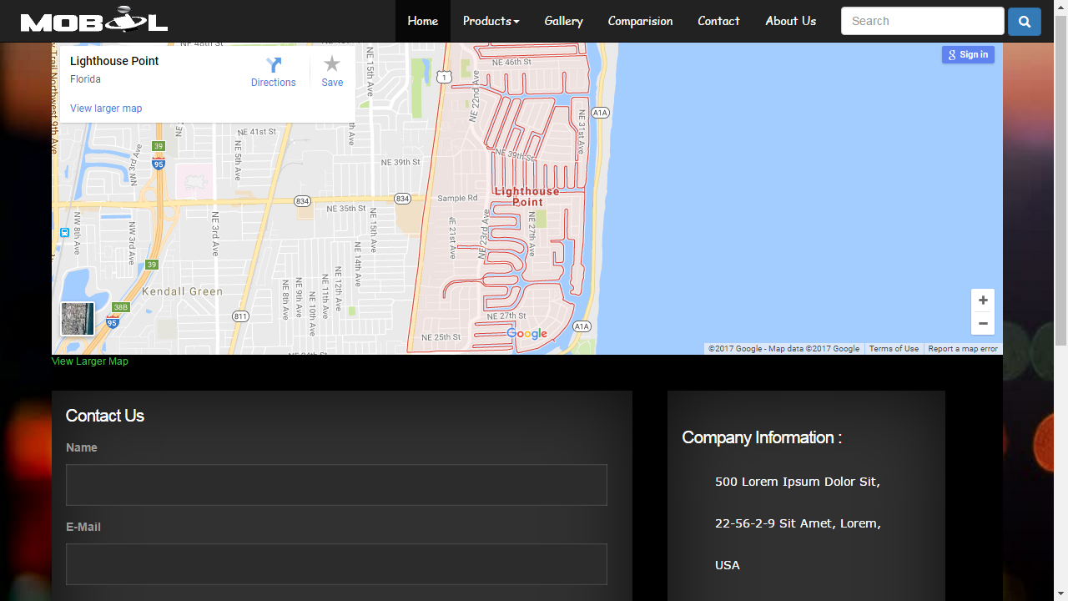

About-us

